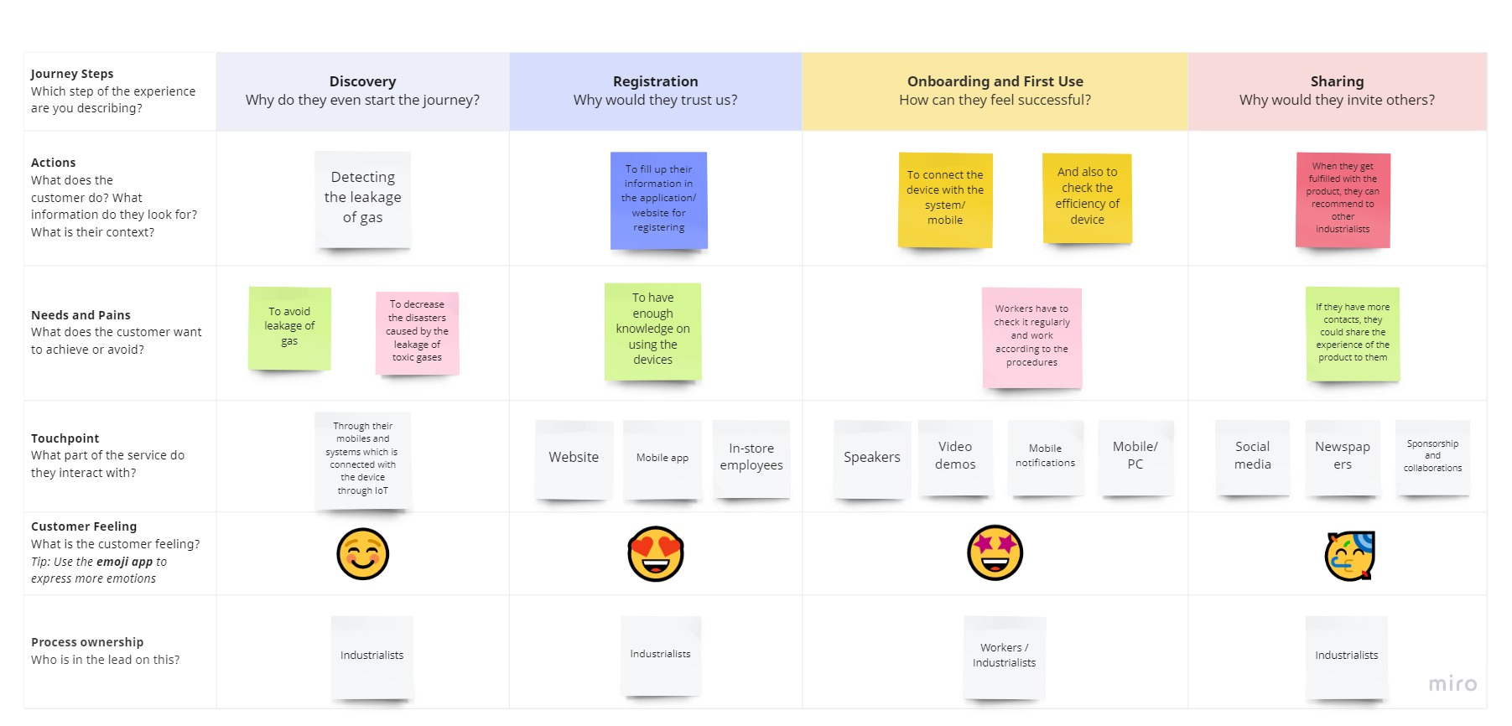
Project Design Phase-II
Customer Journey

Date | 10/07/22
Team ID | PNT2022TMID15909
Project Name | Gas leakage monitoring and alerting system for industries

